**CSC 417 Unit 2 Day 4 Outline**

1. Additional Convolutional Neural Network concepts
   1. Activation
      1. Convolutional layers often use the ReLU activation function

*f(x) = max(0, x)*

* + 1. Chart, line chart

       Description automatically generatedAdvantages:
       1. Simpler computation
          1. Derivative always = 1 for positive input
       2. Representational sparsity
          1. Can output zero values
       3. Linearity
          1. Easier to optimize
    2. Disadvantages
       1. “Dying ReLU”
          1. Once neuron goes negative, it is unlikely to “recover” because slope of any negative value is 0
  1. Padding
     1. 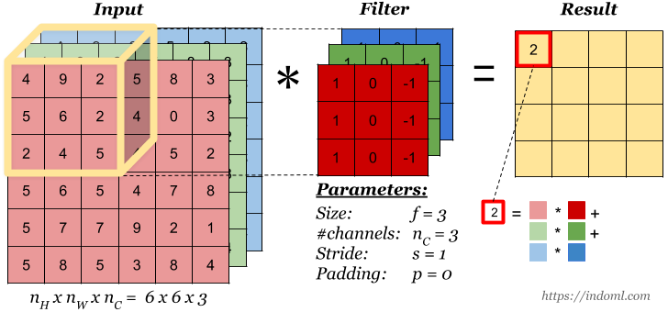Convolution layers reduce output volume (e.g. result in a smaller image)
        1. Information on the border  
           of an image is not captured  
           well by the network
     2. Pooling also results in   
        a reduced output volume
     3. Padding addresses this problem by adding “extra” information around the edge of the data
        1. Same/Zero padding
           1. Adds zeros of the edge of layer output
        2. Constant padding
           1. Adds a user-specified constant value at the edges
        3. Reflection padding
           1. Adds “mirror values” in opposite direction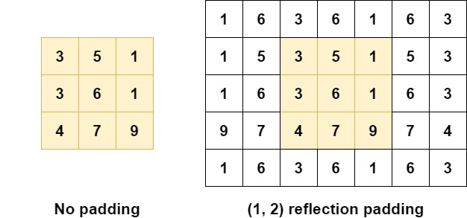
        4. Replication/symmetric padding
           1. Copies and mirrors values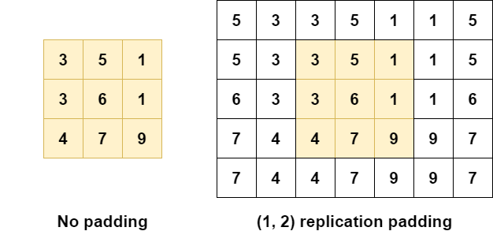
     4. Zero and same padding change the distribution of the data and are generally not recommended

1. Philosophy of AI
   1. Despite our attempts to duplicate the human brain, we don’t seem to be any closer to a true duplication of human intelligence…